<<20130425>> Archived distributions can be retrieved at; <http://tinyurl.com/azg3eyl <http://tinyurl.com/azg3eyl> >. This archive includes a html version of this list distribution and its MS/WORD version with its filename as “year-month-date.doc.” You can also access all of its attachments, if any.
Prof. Edwin Scott Asemota, MD, DTMPH, FMEC, Phd. <Scotta-Help-point@t-online.de>
Ms. Astrid Hogmo <astrid.hogmo@me.com>
Francisco (Paco) Bozzano-Barnes <francisco@tenureecology.com>
Aomar Benslimane, Ph.D. <abensnyc@aol.com>
Youcef Oubraham <Youcef.oubraham@stevens.edu>
Michael Scalero <mscalero@stevens.edu>
Prof. Victor B. Lawrence <Victor.Lawrence@stevens.edu>
P. Tapio Varis, Ph.D., Professor <tapio.varis@uta.fi>
princess claudia windisch graetz <dashaeusle@t-online.de>
Maria Lourdes B. Toloza <mtoloza@stevens.edu>
References:
(a) (20130422) Report on “Public Seminar on African Broadband Internet and Early Warning System Launch” held at the Stevens Institute of Technology on April 18, 2013
<http://tinyurl.com/berm8k9>
(b) Agenda of “Public Seminar on African Broadband Internet and Early Warning System Launch,” which is to be held at the Stevens Institute of Technology on April 18th
<http://tinyurl.com/cylach6>
View the Blackboard Collaborate recording
<https://sas.elluminate.com/site/external/jwsdetect/playback.jnlp?psid=2013-04-18.0639.M.03E3D7E337890D94998E11A7F9C3D0.vcr&sid=2012174>
Note:
(1) Copy this URL without breaking and copy into the address line of your browser.
(2) You have to have the latest JAVA before downloading this recording file.
(3) If you are using TEXTWRANGLER, remove it from your laptop, since it impedes the opening of the downloaded recorded file for your viewing with the Blackboard Collaborator.

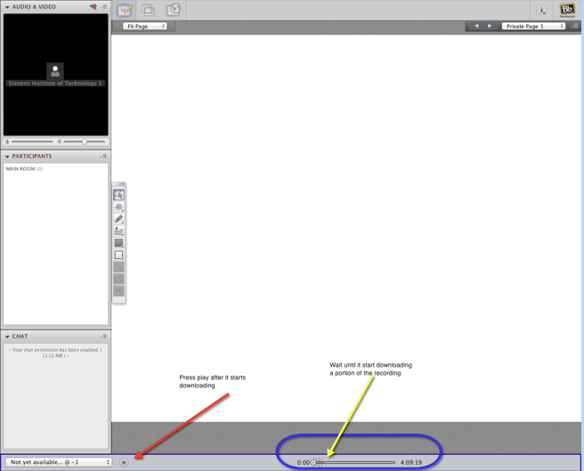

(c) Brief overview of conference and areas of agreement
<http://tinyurl.com/bpxvzga>
Dear Edwin:
(1) Many thanks for your msg (ATTACHMENT I below) in response to the Reference (a) above.
(2) I am very delighted that you noticed my words at the end of the Reference (a) above;
“This April 18th event was the initiation of constructing the Electronic United Nations!! -- Hence, Let’s work together!!”
As I said during my presentation, our approach is autonomous democratic compared with autocratic totalitarian approach which often ignores the National Boundaries, the very basic social infrastructure, in most of aggregating simulation models, as violating the very basic iron rule of simulation — i.e., “Make simulation as much close to SIMULAND as possible” -- here the SIMULAND is the target of the simulation.
The main purpose of our GEWS/GUS is to promote rational scientific approach for decision-making with critical thinking for the capacity building of bureaucrats and young aspiring future leaders.
(3) Pls visit Reference (a) above to retrieve appropriate info of our GLH/ECOWAS videoconferencing event at the Stevens Institute of Technology on April 18th.
Pls also make sure to retrieve the file which recorded the entire session in the Reference (b) above.
If you have a second computer screen, you may display the presentation slides of Tapio, Victor, Hans and mine (*) while you watch their presentation in the recorded file on your first screen — by this way, you can read small letters appeared in the Blackboard Collaborator webcam on the latter screen.
(*) You can download those slides in the References I sited in the Reference (a) above.
Dear Paco:
(4) Many thanks for your succinct minutes of our session (Reference (c) above).
Dear ECOWAS colleagues in Benin, Nigeria and Sierra Leon:
(5) Sorry we could not have you during our 4/18th event.
Pls come in our next rehearsal, which I will inform to you soon. I would like to do this prior to our workshop at the GLORIAD office at the University of Tennessee in Knoxville (UTK) with the NSF fund.
Keep in touch.
Best, Tak

ATTACHMENT I
From: "Scotta-Help-point@t-online.de" <Scotta-Help-point@t-online.de>
Subject: Re: [gu-new] (20130422) Report on ³Public Seminar on African Broadband Internet and Early Warning System L aunch² held at the Stevens Institute of Technology on April 18, 2013
Date: April 24, 2013 8:14:19 PM EDT
To: takutsumi0@gmail.com
Reply-To: "Scotta-Help-point@t-online.de" <Scotta-Help-point@t-online.de>
Thanks a million Tak for your total commitment and outstanding leadership prowess.
They made the ECOWAS focused Video-conferencing an unequivocal success on April 18, 2013.
I am looking forward to viewing the Blackboard Collaborate recording of the event.
You got it right there, this could be ' The initiation of constructing the Electronic United Nations'
Sure, you can count on all of us to work together and sustain this momentum, is just great to see history in the making !
Paradoxically however, the Health care and the Community development officers at the ECOWAS headquarters in Abuja, Nigeria who I spent days prompting to participate in the event did not in. They also did not follow-up to explain what problems they may have had if any at-all, in accessing the 'Blackboard'
Victor, Mike, Youcef and other team-players at the Stevens Institute, you did a marvelous job.
The Blackboard collaboration approach was unique and first time ever in Africa.
I have also not seen it used here in Germany either.
More grease to your elbows.
Guess the flowers have started sprouting over-there as we have right now in Germany.
Enjoy the fresh fragrance of Spring.
Best, Edwin

ATTACHMENT II
(Photos taken during the GLH/ECOWAS event)
Astrid and Paco: Many thanks for these photos.
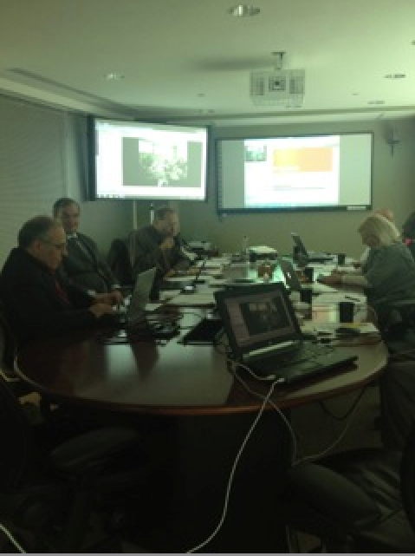
Photo 1 at the session room:
<http://tinyurl.com/ab82qk2>
Left: Aomar Benslimane, Tapio Varis, Tak Utsumi
Right: princess claudia windisch graetz
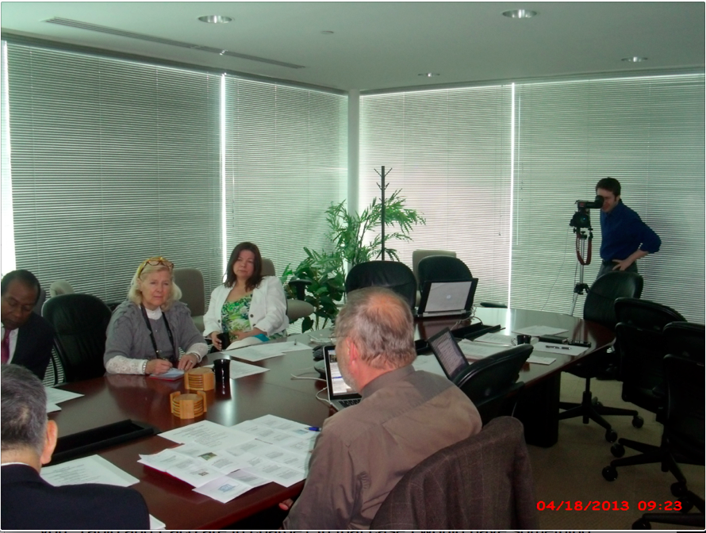
Photo 2 at the session room:
<http://tinyurl.com/aad7mtk>
Left: Victor Lawrence, princess claudia windisch graetz, Astrid Hogmo
Right: Tapio Varis, Michael Scalero (at camera)
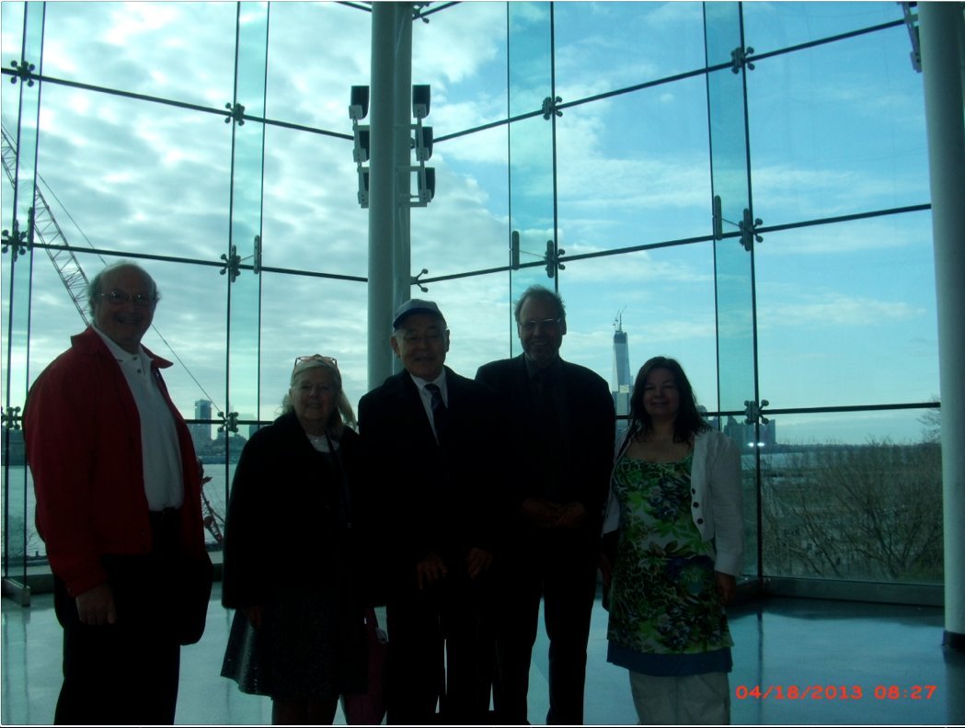
Photo 3 Background of skyscrapers around Wall Street in Manhattan:
<http://tinyurl.com/a3khkav>
Left: Youcef Oubraham, princess claudia windisch graetz, Tak Utsumi, Tapio Varis, Astrid Hogmo
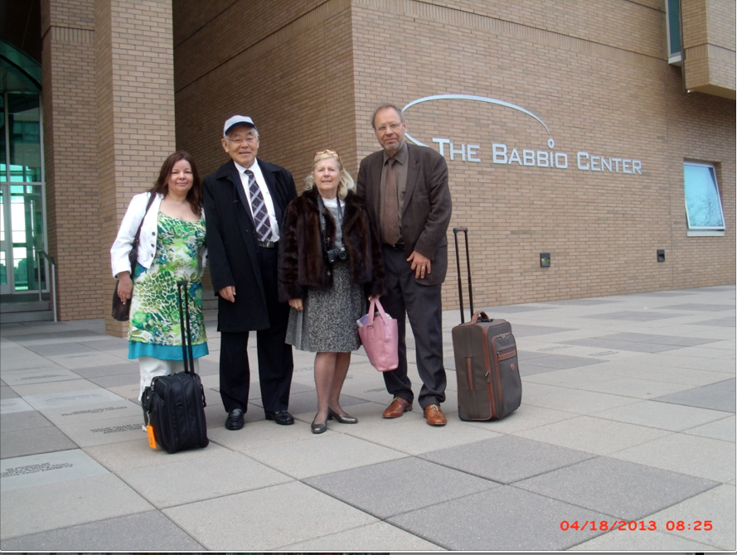
Photo 4 at the front of building where the session was held:
<http://tinyurl.com/d8smjz3>
Left: Astrid Hogmo, Tak Utsumi, princess claudia windisch graetz, Tapio Varis
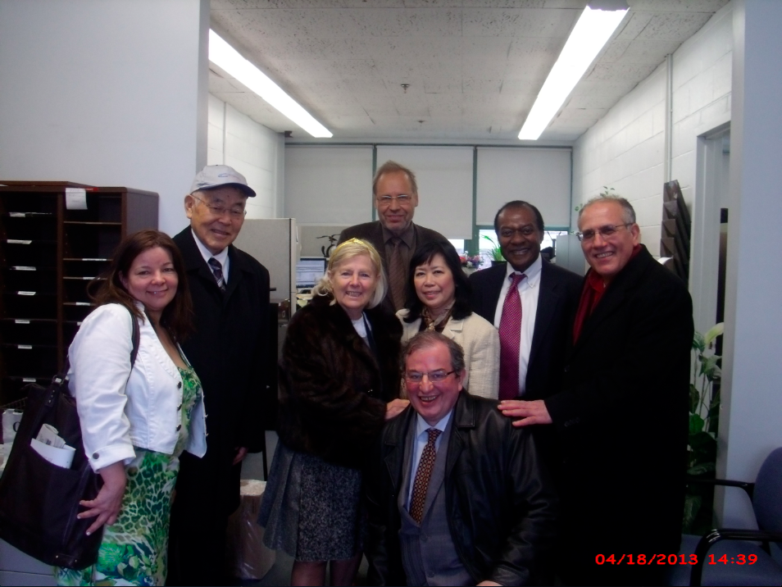
Photo 5 at Maria’s room:
<http://tinyurl.com/bblt9ak>
Left: Astrid Hogmo, Tak Utsumi, princess claudia windisch graetz, Tapio Varis, Maria Lourdes B. Toloza, Victor Lawrence, Aomar Benslimane
Front: Francisco (Paco) Bozzano-Barnes
Photo 6 as waiting for a bus back to New York:
<http://tinyurl.com/abgn9mk>
Left: Aomar Benslimane, Tapio Varis, Tak Utsumi, princess claudia windisch graetz, Astrid Hogmo,
Front: Francisco (Paco) Bozzano-Barnes

List of Distribution
Prof. Edwin Scott Asemota, MD, DTMPH, FMEC, Phd.
Prof. of Medicine and CEO,
Help Point International Foundation
Heidelberg, Germany
Cel: 661-748-0240
Phone in Germany: ( + 49) 1578-7144-074 Phone in Nigeria: ( +234) 81-6776-5921
Skype: Edwin. Scottglobal
Scotta-Help-point@t-online.de
Helpinglife@live.com
Ms. Astrid Hogmo
Network Architect
Nettverksarkitekt
Studiesenteret.no
Strandveien 6a
9350 Sjovegan
Norway
+47 99434031
astrid.hogmo@me.com
Skype: astridhogmo
http://www.studiesenteret.no
Francisco (Paco) Bozzano-Barnes
Director
Tenure & Ecology LLC
4705 Center Blvd., Apt 406
Long Island City, NY 11109
718-433-4830
Cel: 646-897-2649
francisco@tenureecology.com
www.tenureecology.com
Bio and photo: http://tinyurl.com/6jljtrd
CV: http://tinyurl.com/37fmf8v
Detailed resume <http://tinyurl.com/ybd4knq>
Aomar Benslimane, Ph.D.
President
AB4World
139 Linnet st Bayonne, NJ 07002
Cell: 201 388 1586
abensnyc@ aol.com
abenslimane@ab4world.com
www.AB4World.com
Youcef Oubraham
E-Learning Technologies Administrator
Library Systems Administrator
Information Technology
Stevens Institute of Technology
Castle Point on Hudson
Hoboken, NJ 07030
Phone: 201-216-5418
Youcef.oubraham@stevens.edu
Michael Scalero
E-Learning Technology Manager
Information Technology
Stevens Institute of Technology
The Innovation University
Castle Point on Hudson
Hoboken, NJ 07030
201-216-5475
Cel: 201-805-7551
Fax: 201-216-8960
mscalero@stevens.edu
www.twitter.com/mscalero
www.stevens.edu
Prof. Victor B. Lawrence
Associate Dean: Special Topics
Batchelor Chair Professor of Electrical Engineering
Department of Electrical & Computer Engineering
Burchard Building, Room 205
Stevens Institute of Technology
Castle Point on Hudson
Hoboken, NJ 07030
Ph.: 201 216-5636
Cel: 732-407-9500
Fax.: 201 216-8246
Victor.Lawrence@stevens.edu
http://www.ece.stevens-tech.edu/iNetS/people/LawrenceVita.html -- brief bio
http://www.stevens.edu
P. Tapio Varis, Ph.D., Professor
Acting President, Global University System
UNESCO Chair in Global e-Learning with applications to multiple domains
Professor and Chair of Media Education
Research Center for Vocational Education & Hypermedia Laboratory
University of Tampere
P.O.Box 229
FIN-13101 Hameenlinna
FINLAND
+358-3-3551-3608
Tel: +358-3-614-5608--office in Hameenlinna
Tel: +358-3-215 6243--mass media lab in Tampere
GSM: +358-50-567-9833
Fax: +358-3-614-5611 or +358-3-3551-3611
tapio.varis@uta.fi
tapio.varis@hamk.fi
tapio.varis@helsinki.fi
http://www.uta.fi/~titava
www.ecml-eu.org -- about ECML project.
http://www.uta.fi/conference/mediaskills/
prince gottfried and princess claudia windisch graetz
exec. producer,writer and directors of:
GLOBAL SATELLITE BROADCASTING FOR CULTURE;EDUCATION AND SCIENCE
INTERNATIONAL COMMUNICATIONS NETWORK
ECOLOGY AND ELECTRONIC ENVIRONMENT CORP
tele: OO49-07934-993724
das haeusle
am graben 6
97990 weikersheim
baden wurtemburg Germany
dashaeusle@t-online.de
Maria Lourdes B. Toloza
Department of Electrical & Computer
Engineering (Burchard Building)
STEVENS INSTITUTE OF TECHNOLOGY
Castle Point on Hudson
Hoboken, NJ 07030
201-216-5623 (v) 201-216-8246 (f)
mtoloza@stevens.edu
or
Electrical and Computer Engineering Department
Stevens Institute of Technology
Burchard 212
Hoboken, NJ 07030

*******************************************************************************
Takeshi Utsumi, Ph.D., P.E., Chairman
GLObal Systems Analysis and Simulation Association in the U.S.A. (GLOSAS/USA)
Laureate of Lord Perry Award for Excellence in Distance Education
Founder and V.P. for Technology and Coordination of Global University System (GUS)
43-23 Colden Street, #9L, Flushing, NY 11355-5913, U.S.A.
Tel: 718-939-0928; Cel: 646-589-1730; Skype: utsumi
Email: takutsumi0@gmail.com, Web: http://www.friends-partners.org/GLOSAS/
U.S./IRS Employer ID: 11-2999676 <http://tinyurl.com/534gxc>
New York State Tax Exempt ID: 217837 <http://tinyurl.com/47wqbo>
Google Profiles <https://profiles.google.com/takutsumi0/about>
Facebook <http://www.facebook.com/GlobalEarlyWarningSystemsgews>
List Distribution <http://tinyurl.com/2fzx23e>
*******************************************************************************

